<https://leetcode.com/discuss/interview-question/907575/Amazon-or-OA-2020-or-Winning-Sequence>

public static int[] sequence(int length, int upperBound, int lowerBound) {

int bound = (upperBound - lowerBound) \* 2 + 1;

if(bound < length) return new int[]{-1};

int[] arr = new int[bound];

int lower = lowerBound;

int x = 0;

while(lower < upperBound && x < arr.length) {

arr[x++] = lower++;

}

int pivot = x;

int upper = upperBound;

while(x < arr.length && upper >= lowerBound) {

arr[x++] = upper--;

}

if(bound <= length) return arr;

int min = Math.min(arr.length, pivot + length - 1);

return Arrays.copyOfRange(arr, min - length, min);

}

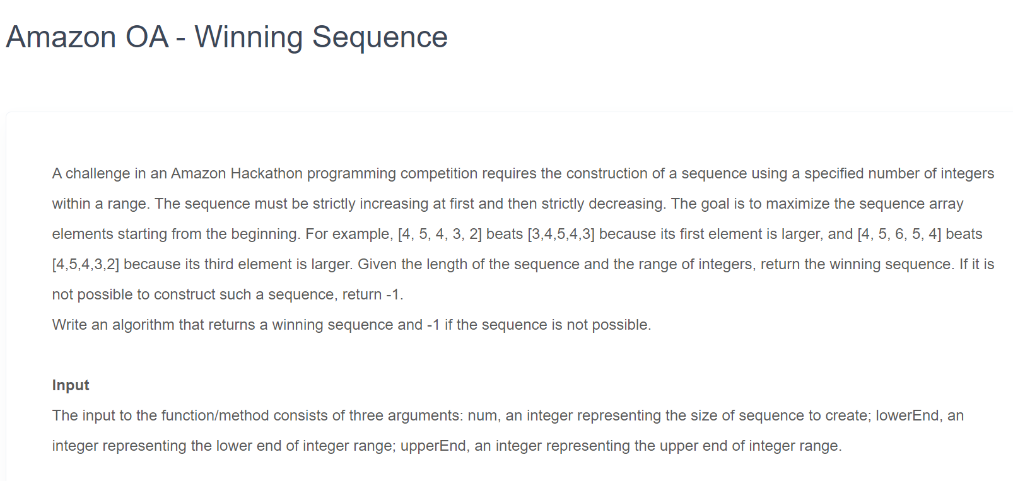

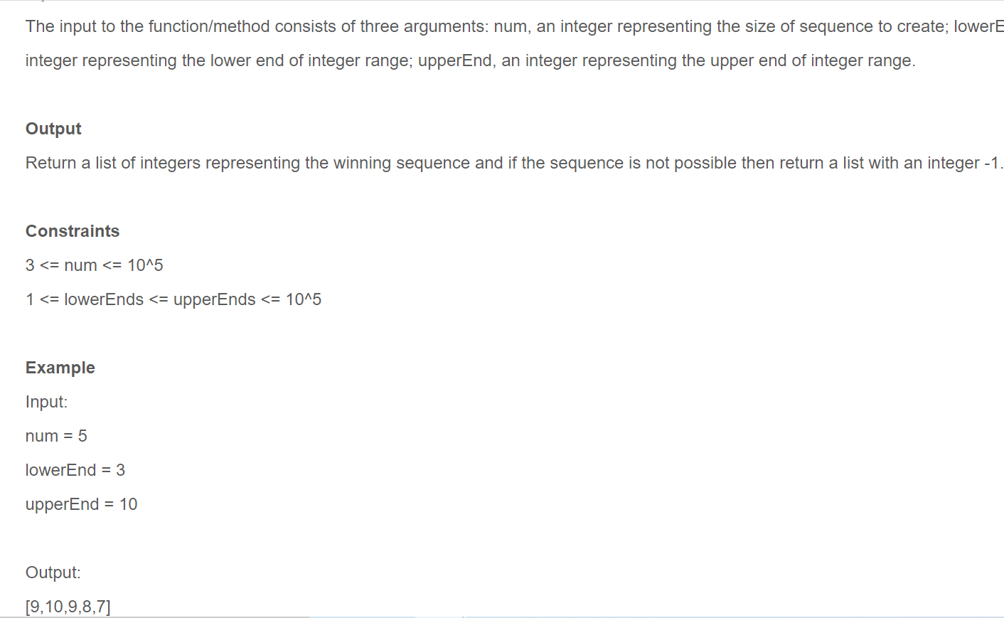

import java.util.Arrays;

public class HelloWorld{

public static void main(String []args){

int count=5;

int lowerEnd = 2+1;

int upperEnd = 5+5;

int len = Math.max(1+(upperEnd-(upperEnd-lowerEnd))\*2, 1+(upperEnd-lowerEnd)\*2);

int[] arr = new int[len];

int start = lowerEnd;

for(int i=0;i<=arr.length/2;i++){

arr[i]= start;

if(i!=arr.length/2)

arr[arr.length-i-1]=start;

start++;

}

//System.out.println(Arrays.toString(arr));

int[] res = new int[count];

if(arr.length<count)

System.out.println("not possible");

else{

res[0]=arr[arr.length/2-1];

for(int i=1,j=arr.length/2;i<res.length;i++,j++){

res[i]=arr[j];

}

}

System.out.print(Arrays.toString(res));

}

}